1) GSTN format validation is applicable only for India. GSTN can be mentioned as GSTIN or tax identification number in common
In case, if we enter the overseas address, the pin code should be mentioned as pin code or zip code. 6 digits validation is not valid for overseas.
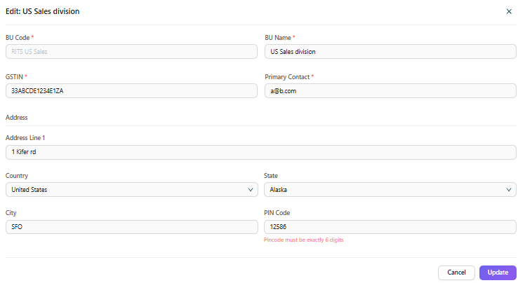
2) when I create a new business unit, it asks for place of supply.
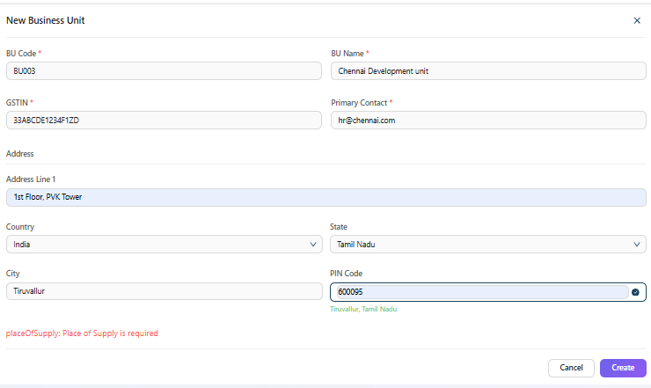

3) when I select business unit, it directly goes to edit mode. We can't we keep the edit button under the “ACTION” ? When we select the business unit, only the details can be displayed. Only when we intentionally try to edit can we click the edit button and do the edit.
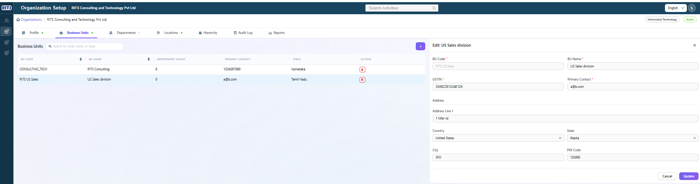

4) when I try to add one department under a business unit, the parent dept field drop-down list shows some of the departments which do not exist at all.
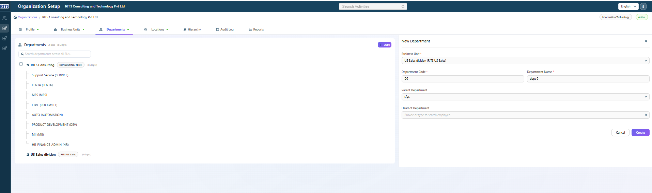

5) Even after point number 4 issue, I could create one department but it is not showing under the business unit.
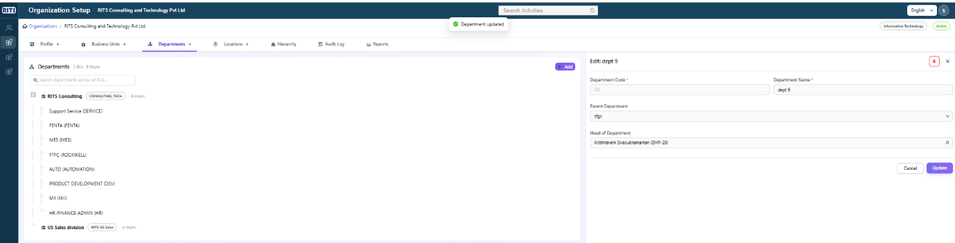

6) Similar to business unit, in the department also, if I select a department, it's directly going for edit mode. There should be an edit button for intentional editing. When I select the particular department, it should just show the department details.
7) The newly created department under US Sales business unit is not at all showing in any of the tabs.
8) what is the purpose of the Locations tab? Currently it seems we need to add some locations manually. But we have already discussed that it should capture the departments or business unit we have already entered and show in this tab.
9) Scroll bar required in Hierarchy screen
